Home-based Edge–cloud Resource Management and Evaluation System (HERMES): A Privacy-preserving Framework for Personalized Menopausal Health Monitoring

1. Abstract
Menopausal health is a critical yet underrepresented domain, affecting over one billion women globally and driving one of the fastest-growing markets in femtech innovation. As a long-term physiological transition associated with multiple chronic health challenges, menopause requires continuous, real-world monitoring that current clinical settings fail to provide. To address this need, the HERMES is developed for home-based monitoring of menopausal progression, enabling reliable and personalized modeling of long-term physiological and behavioral dynamics. The system integrates heterogeneous data from wearable sensors and cameras, using context-aware filtering to exclude non-home activities, visitors, and pets. On-device modules perform cross-attention alignment, confidence-aware masking, and multimodal fusion to generate stable, anonymized physiological embeddings stored in encrypted buffers. Communication with the cloud is optimized through gradient compression, adaptive synchronization, and privacy-preserving parameter updates. The cloud subsystem conducts secure aggregation, personalized model adaptation, and expert-in-the-loop validation using limited clinical and hormonal data to enhance generalization without exposing raw home information. This closed-loop architecture enables robust multimodal representation, efficient communication, and full compliance with data-protection regulations, supporting scalable and ethical menopause-focused digital health applications.
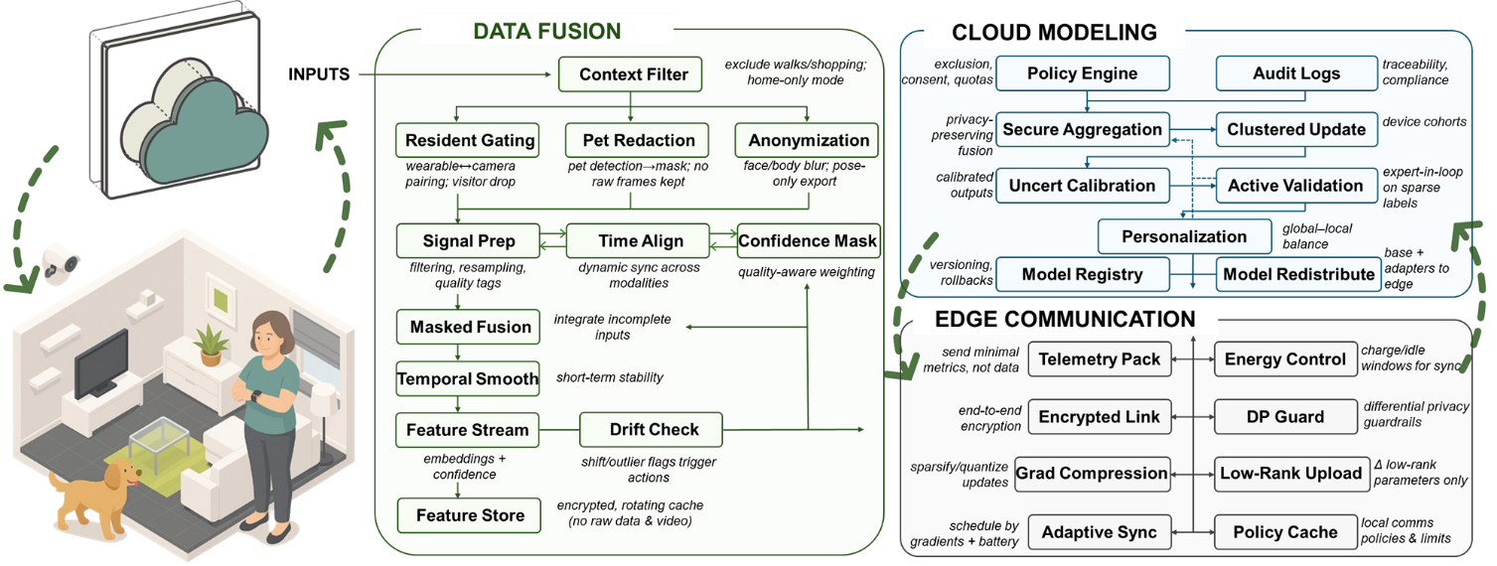
Figure 1 System Architecture of HERMES

2. Technical Route

Technical Route 1: Robust Multimodal Fusion in Home Environments

2.1.1 System Design
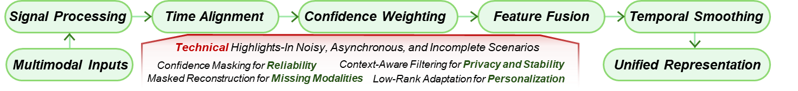
Figure 2 Framework of Technical Route 1
This design develops a locally deployable multimodal fusion network capable of long-term operation in home environments to extract stable physiological representations from heterogeneous sensor data. The system synchronizes temperature, heart rate variability, motion, and environmental variables through cross-attention alignment and signal confidence modeling. The core Masked Multimodal Transformer combines masked modeling with cross-modal contrastive learning to learn a shared latent space and generate temporally continuous embeddings. The resulting health feature stream is processed on-device through confidence weighting and temporal smoothing to produce structured and stable physiological representations, providing consistent input for subsequent tasks.

2.1.2 Technical Challenges and Solutions
In home scenarios, signals often exhibit high noise, asynchrony, and missing modalities. To address these issues, the HERMES introduces a confidence mask mechanism during encoding. This mechanism down-weights abnormal segments based on signal quality scores and maintains contextual consistency through masked attention layers, suppressing short-term interference. For missing modalities, a masked reconstruction strategy is adopted to recover critical dynamic features, allowing the model to maintain temporal continuity even when partial data is unavailable. All feature extraction is executed locally, and the system incorporates low-rank adapter parameters to support subsequent on-device personalization.

2.1.3 Expected Outcomes
The system is expected to significantly improve multimodal feature stability and temporal consistency on real-world home datasets. The generated physiological representations will demonstrate cross-day alignment and physical coherence, serving as high-quality input for downstream predictive models. All data processing and model operations are performed within the edge device, ensuring full privacy compliance and enabling sustainable long-term adaptive learning.

Technical Route 2: Reliable Modeling & Validation under Sparse Clinical Labels

2.2.1 System Design
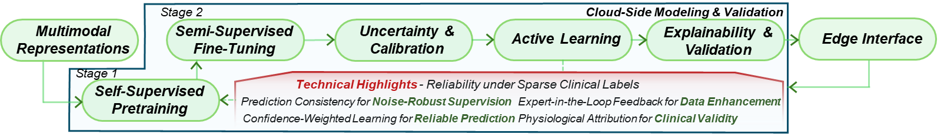
Figure 3 Framework of Technical Route 2
This design addresses the challenge of sparse and subjective clinical labels in menopausal health monitoring by developing a weakly supervised modeling framework with uncertainty quantification and active validation mechanisms. The system employs a semi-supervised temporal network for health state prediction. Model training is conducted in two phases. In the first phase, self-supervised temporal pretraining is performed on unlabeled data to capture long-term physiological rhythms and provide a prior for subsequent few-shot learning. In the second phase, fine-tuning is performed using limited clinical scores and hormone measurements, supplemented by auxiliary proxy tasks to provide structural supervision signals and enhance sensitivity to latent physiological abnormalities.

2.2.2 Technical Challenges and Solutions
The main challenges at this stage include label sparsity, subjectivity, and overfitting risk. To mitigate these issues, consistency regularization is applied to enforce temporal smoothness across predictions in adjacent time windows, reducing the effect of noisy labels. Uncertainty estimation using deep ensemble and Bayesian dropout is integrated to evaluate prediction reliability. When the confidence level is low, an active learning mechanism is triggered to request expert review or additional data collection, progressively improving data representativeness. Attention visualization and SHAP analysis are employed to constrain the model to focus on physiologically relevant features.

2.2.3 Expected Outcomes
The system is expected to achieve stable physiological trajectory prediction under sparse label coverage and produce outputs with quantified confidence intervals. The framework integrates continuous home monitoring with periodic clinical evaluation, enabling consistent health state modeling across scenarios. It provides a foundation for personalized and enterprise-level health management applications.

Technical Route 3: Balancing Edge Computing, Communication, and Privacy Protection

2.3.1 System Design
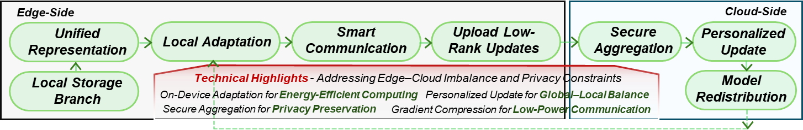
Figure 4 Framework of Technical Route 3
This design proposes a hierarchical federated learning framework to enable edge–cloud collaborative modeling under strict privacy protection. The system consists of edge clients and a cloud-based coordination subsystem. Each client performs on-device fine-tuning of multimodal representation and prediction models and uploads only low-rank parameter updates. The cloud subsystem aggregates these updates using secure aggregation and differential privacy algorithms, then periodically distributes updated global models back to the edge devices. Communication between edge and cloud integrates gradient compression and adaptive asynchronous synchronization to maintain training stability under bandwidth limitations and network heterogeneity.

2.3.2 Technical Challenges and Solutions
Limited edge computing resources and non-ID data distributions can destabilize global model convergence. To overcome this, the system adjusts communication frequency adaptively based on gradient variation to cut redundant synchronization and energy cost. On the cloud, a personalization regularization term balances global sharing and local adaptation, while clustered aggregation groups updates by signal or device type to alleviate heterogeneity. An energy-aware synchronization mechanism with version control further ensures sustainable and traceable operation.

2.3.3 Expected Outcomes
The framework is expected to achieve a substantial reduction in communication load while ensuring full compliance with data protection regulations. It provides privacy-preserving, energy-efficient, and scalable operation, supporting large-scale distributed health monitoring and forming a sustainable edge–cloud collaborative intelligence architecture.

3. Summary and Outlook
HERMES establishes a privacy-preserving framework for home-based menopausal health monitoring, integrating multimodal sensing, uncertainty-aware modeling, and edge–cloud collaboration. The system enables stable physiological representation, reliable prediction under sparse labels, and secure large-scale adaptation. Future work will focus on longitudinal validation, optimization of on-device resource management, and interoperability with clinical and wearable ecosystems. These efforts aim to support practical, trustworthy, and regulation-compliant deployment of personalized menopausal health monitoring.

